For homework you have:

* identify problems,
* propose solutions / modification of schemes

• merge

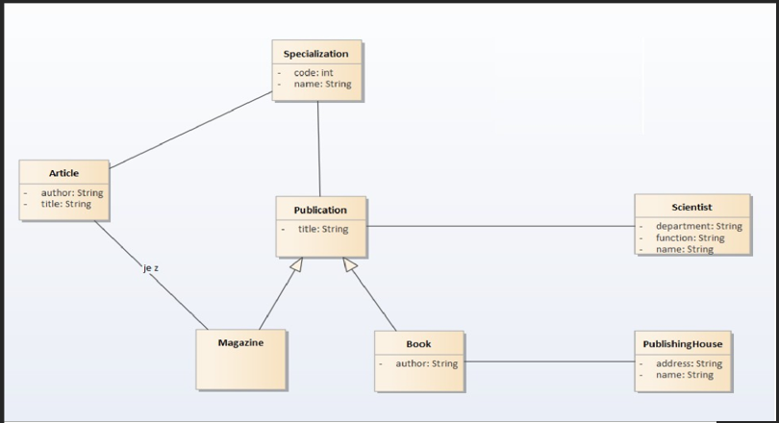

* class magazine without attributs (publishing date ?)
* attribut name publication ?
* no cardinality
* article publishing date ?
* 